Name: ARUNAVA DEY

Roll:11500117123

Q1. How to write shell script that will add two nos, which are supplied as command line argument, and ifthis two nos are not given show error and its usage.

**if [ $# - lt 2]**

**then**

**echo “error”**

**exit 1**

**fi**

**sum=$(($1 + $2))**

**echo “Sum = $sum”**

baba1

Q2. Write Script to find out biggest number from given three nos. Nos are supplies as command lineargument. Print error if sufficient arguments are not supplied.

GNU nano 2.5.3 File: baba2.sh

**if [ $# -lt 2 ] || [ $# -gt 3 ]**

**then**

**echo "error"**

**exit 1**

**fi**

**maxel=$1**

**for arg in "$@"**

**do**

**if [ "$arg" -gt "$maxel" ]**

**then**

**maxel=$arg**

**fi**

**done**

**echo "largest value is: $maxel "**

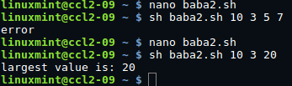

Q3. Write script to print nos as 5,4,3,2,1 using while loop

GNU nano 2.5.3 File: baba3.sh

**n=5**

**while [ $n -gt 0 ]**

**do**

**echo "$n"**

**n=$(( n-1 )) # decrements $n**

**done**

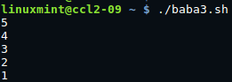

Q4. **Write Script, using case statement to perform basic arithmetic operation.**

GNU nano 2.5.3 File: baba4.sh

echo Enter the a value

read a

echo Enter the b value

read b

echo 1.Addition

echo 2.Subtraction

echo 3.Multiplication

echo 4.Division

echo Enter your choice

read choice

case $choice in

1)echo Addition : $(expr $a + $b);;

2)echo Suubtraction : $(expr $a - $b);;

3)echo Multiplication : $(expr $a \* $b);;

4)echo Division : $(expr $a / $b);;

*)echo This is not a choice

esac

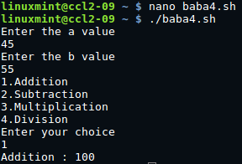

Q5.Write Script to see current date, time, username, and current directory

GNU nano 2.5.3 File: baba5.sh

echo “Hello, $LOGNAME”

echo “Current date is `date`”

echo “User is `who i am`”

echo “Current direcotry `pwd`”

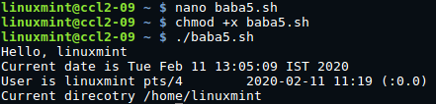

Q6. Write script to print given number in reverse order, for eg. If no is 123 it must print as 321

GNU nano 2.5.3 File: baba6.sh

**echo "Enter a number"**

**read n**

**sd=0**

**rev=0**

**while [ $n -gt 0 ]**

**do**

**sd=$(( $n % 10 ))**

**rev=$(( $rev * 10 + $sd ))**

**n=$(( $n / 10 ))**

**done**

**echo "Reverse number of entered digit is $rev"**

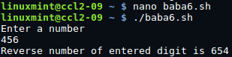

Q7. **Write script to print given numbers sum of all digit, For eg. If no is 123 it's sum of all digit will be 1+2+3 = 6.**

GNU nano 2.5.3 File: baba7.sh

echo "Enter a number"

read n

d=0

sum=0

while [ $n -gt 0 ]

do

d=$(( $n % 10 ))

sum=$(($sum + $d))

n=$(( $n / 10 ))

done

echo "sum of entered digit is $sum"

baba7

Q8. **How to perform real number calculation in shell script and store result to**

**third variable , lets say a=5.66, b=8.67, c=a+b?**

GNU nano 2.5.3 File: baba8.sh

a=5.66

b=8.67

c=`echo $a + $b | bc`

echo "$a + $b = $c"

baba8

Q9. **Write script to determine whether given file exist or not, file name is supplied as command line argument, also check for sufficient number of command line argument**

GNU nano 2.5.3 File: baba9.sh

echo "The name of the script file is $0"

echo "Total number of arguments passed to the script = $#"

if [ $# -gt 0 ]

then

echo "List of arguments:"

for arg in $@

do

echo "$arg"

done

else

echo "No argument provided to the script."

fi

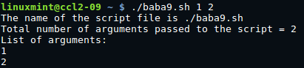

Q10. **Write script to print contains of file from given line number to next given number of lines. For e.g. If we called this script as Q13 and run as**

**$ Q13 5 5 myf , Here print contains of 'myf' file from line number 5 to next 5 line of that file.**

GNU nano 2.5.3 File: baba10.sh Modified

if [ $# -eq 0 ]

then

echo "$0:Error command arguments missing!"

echo "Usage: $0 start_line uptoline filename"

echo "Where start_line is line number from which you would like to print file"

echo "uptoline is line number upto which would like to print"

echo "For eg. $0 5 5 myfile"

echo "Here from myfile total 5 lines printed starting from line no. 5 to"

echo "line no 10."

exit 1

fi

if [ $# -eq 3 ]; then

if [ -e $3 ]; then

tail +$1 $3 | head -n$2

else

echo "$0: Error opening file $3"

exit 2

fi

else

echo "Missing arguments!"

fi

